System modeling
When analyzing and designing any robotic and other mechatronic systems, it is vital that a good dynamic model of the system be developed and used.
Timing belts are a common means of motion transfer between rotating motors/shafts in a machine or mechatronic system.
Since such systems often use some kind of flexible belts for motion transfer, the belt stiffness is a very important parameter in a system model. In cases where the length of the belt is constant (e.g., running between two fixed pulleys), the stiffness k of the belt can be modeled as a spring where f(x) = kx; therefore, the stiffness of the belt is a function of its deflection x under load.
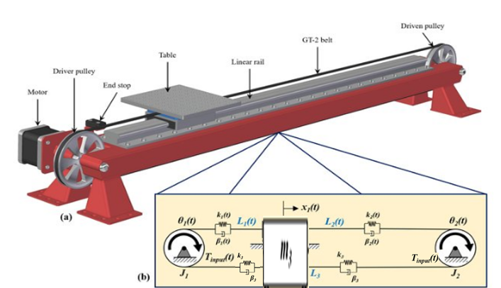
where a GT-style belt is used to transfer motion from a stepper motor to drive a linear positioning system. Also shown is a 2D dynamic model representation, where the differences in effective stiffness, based on belt length, in the belt sections are clearly evident.
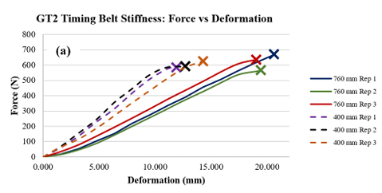
This graph represents the stiffness characteristics of a GT2 timing belt, showing the relationship between force (N) and deformation (mm).
Then
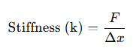
K = 6.5 N/m

The damping coefficient and friction coefficient are related, but they represent different physical phenomena and cannot be directly converted without more context. However, if you're working with a system where frictional damping is the main source of resistance, the damping coefficient can be estimated from the friction coefficient in the following way.

For a simple system with dry friction or viscous friction in a linear model, the damping force is often related to the velocity by the equation:

F = D . v

Where D is the damping coefficient and v is the velocity of the moving part.

If the damping is purely due to friction and you are modeling it as a viscous friction model, the damping coefficient can be estimated as:

D = µ . m . g
µ = 0.5; the friction coefficient between rubber and aluminum

D= 2.4525 N.s/m

F_{total} = m.a + D_{total}.v + K_{total}.x
T_{L} = F_{total} . r_{pulley}

Modeling of stepper motor
A stepper motor is an electromechanical device that transforms electrical pulsations into discrete mechanical motions, and it is a type of synchronous motor that has a high torque and low speed. The rotor rotates in discrete form by applying a sequence of electric pulses that cause the rotations, where the direction of the shaft rotation is directly correlated with the order of the applied pulses. Furthermore, the rotating speed and rotation angle are both based on the input pulses, considering that the position holding must occur without consuming energy.

Mathematical Model of Motor
P is the number of pole pairs of the rotor
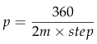

M is the phase number of motor and step is the step angle in degree(1.8⁰).

The maximum flux linkage ψ_{m} is not always specified. This parameter can be obtained experimentally by driving the motor to a constant speed n and by measuring the maximum open-circuit winding voltage Em.
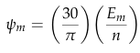

Voltage Equations and Circuit Model
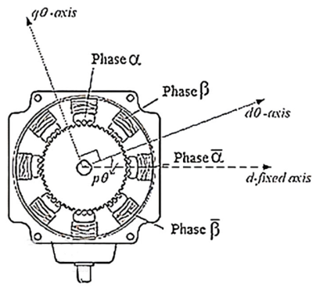
Using the dq transformation, the equations are simplified, resulting in equivalent circuit models for the d and q axes, crucial for simulation and analysis.
As the d-axis represents the flux linkage alignment, while the q-axis indicates the torque alignment.
- Converts the three-phase AC system into a two-axis DC system (d and q components).
- Simplifies the analysis of complex AC systems by making the system behave like a DC circuit in the transformed frame.
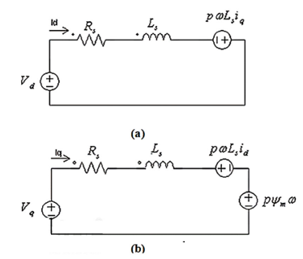
- Helps in understanding how the motor generates torque and how currents interact with the magnetic fields.

Circuit model of stepper motor (a) for d axis, (b) for q axis.

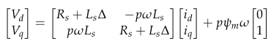

Electromagnetic Torque
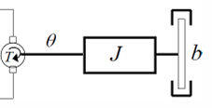
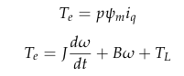

Get the resistance, inductance, rotor inetia and damper from data sheet of the stepper motor (103H7121-5740)
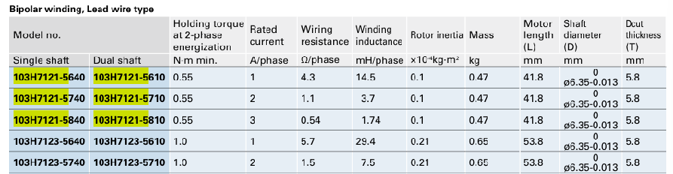

The model in Simulink
